C868 – Software Capstone Project Summary

Task 2 – Section A



Capstone Proposal Project Name: | Patient Scheduling Desktop Application
Student Name: | Jonas M. McCartha

Table of Contents
-------------------
- APPLICATION DESIGN AND TESTING 3
  - Class Design 3
  - UI Design 4
  - Unit Test Plan 5-8
  - Source Code 9
- USER GUIDE 10
  - Installation 10
  - Using the Application 10-16

Application Design and Testing

Design Document

Class Design
The database schema for this program includes six tables and only one-to-many connections between them. The data in general is centered around the appointment table. The appointment table is connected to the user table in a many-to-one relationship in order to facilitate reporting, and is also connected to the patient table in a many-to-one relationship. The address, city, and state tables all represent more detailed patient data.
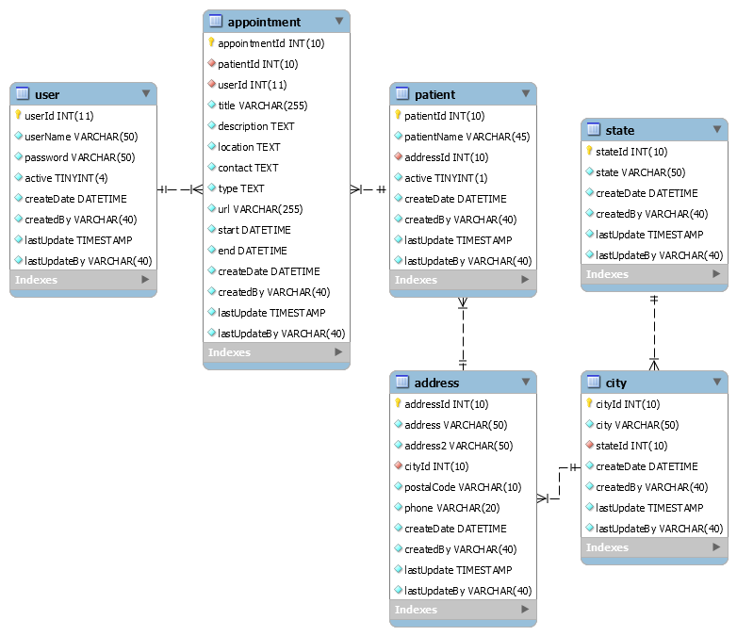

UI Design
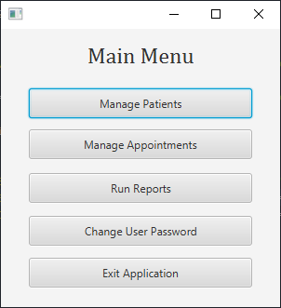
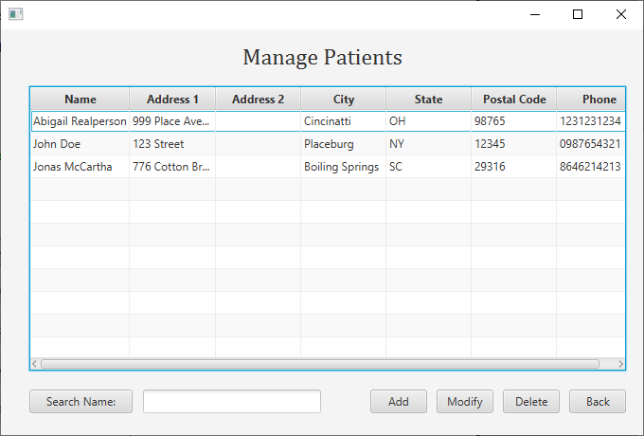
This application uses a straight-forward, minimalist, and clear interface to maximize both speed and readability for users. Fonts and button sizes are normalized across all views.
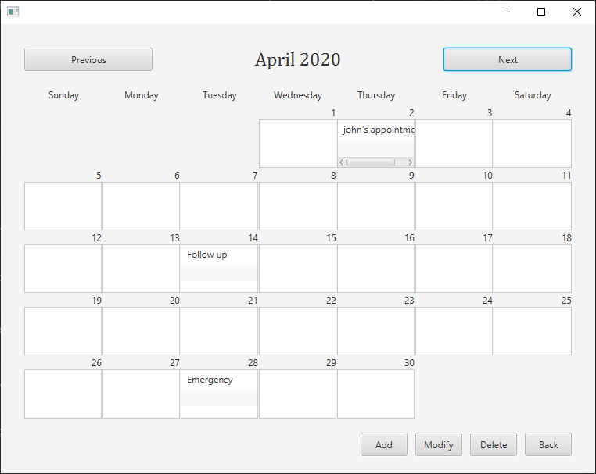

Unit Test Plan

Introduction

Purpose
For a unit test plan for this program, I used Junit 4 to code and execute tests for all public database access methods. These unit tests in totality show and prove that all save, edit, search, and deletion functionality works as intended, independent of the GUI environment.

Overview
The primary functionality of the program is saving, editing, searching, viewing, manipulating, and deleting information inside of a SQL database, through a GUI interface. I had already tested all of the functionality on a practical level, so the primary challenges from proving that it all works as intended through unit testing was writing proper code. However, the process of figuring out this code helped to reify the process that the actual functional methods go through to achieve their goal, and in a few cases I ended up refactoring the original methods being tested.

Test Plan

Items
A test class is created for a given real class, and within this test class, Junit testing code is written for each public method. When the test methods were ready, I executed a 'Run Test' command on the class through the IDE, which runs each method in the test class and then displays unique test results screen.

Features
Each test needs to make an active connection to the database, set up some variables(in most cases), run the original method using these variables, and then compare the result to a pre-defined value of what should happen. If the result and the pre-defined value match as expected, the test passes. If not, something is wrong, either with the original method, or the unit test code.

Deliverables
Each successful test returns a “test passed” message, including the amount of time it took for the test to run. A fully successful test class should return a 100% test success rate to the programmer.

Tasks
The vast majority of the time creating a successful set of unit tests is spent on the coding of the tests themselves. Once all code is correct, completing the unit tests is as simple as executing a 'Run Test' command once on each of the test classes.

Needs
Each test class needs to establish a direction connection to the same SQL database(or a functionally equivalent copy) as the actual classes being tested. To write the actual tests, I used Junit 4, a common unit-testing java framework that has been supported by most IDEs for years. I used this supported functionality in my chosen IDE, NetBeans, to assist in running the actual tests.

Pass/Fail Criteria
The result of the test method and the 'expected' variable are compared at the end of the test. If they match, the test passes. If they don't in any way, the test fails. Of course, the programmer must also make sure that the test does not pass due to a false positive. During the course of writing these tests, the tests that failed were overwhelmingly a result of the test method code needing additional details/variables in order to fully emulate the state from which the original method would run in the production environment.

Specifications
Below is an example of some of the test code written, in this case for the SQLPatient class. This represents test code that successfully passed.
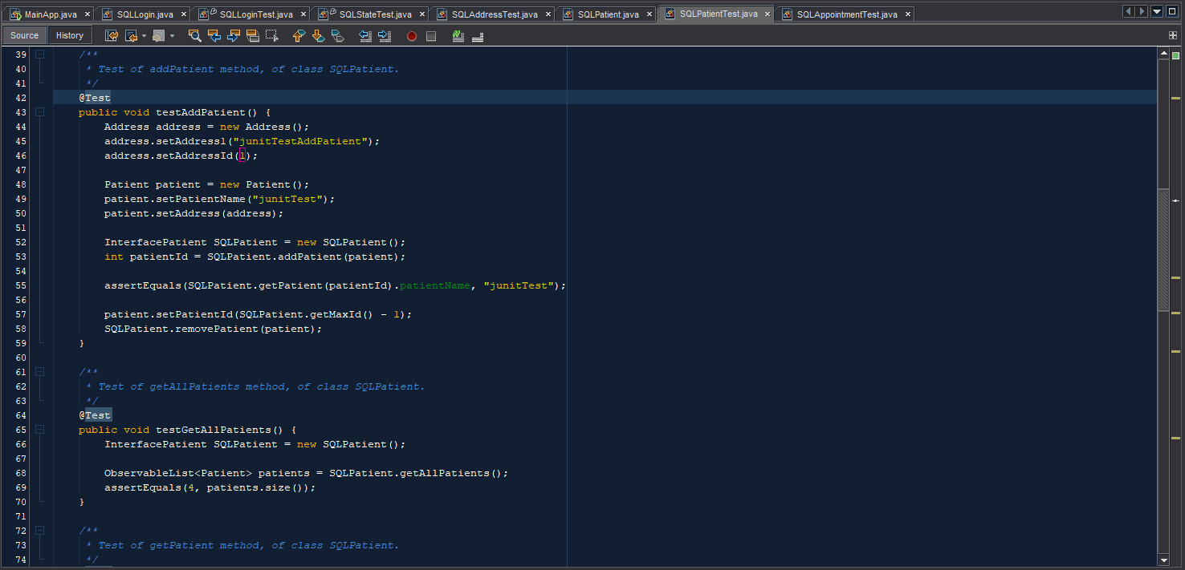

Procedures
  - Identify the classes and methods that should be unit tested
  - Create an equivalent test class for a relevant class that will be tested
  - Write a test case in the test class for each public method in the real class.
  - Test the test class. Where a test fails, revisit that test method to see what needs to be changed. Review the original method if necessary to better understand what you need to change.
  - Once every test is passed, double-check your work and variables, and record the test success.
  - Return to step 2 and repeat for every class that should be tested.

Results
After some in-depth coding and trial-and-error, I created a successful and logical test method for every relevant public method that interacted with the database. Below is a screenshot featuring the Junit4 test results in the bottom, as well as more relevant testing code.
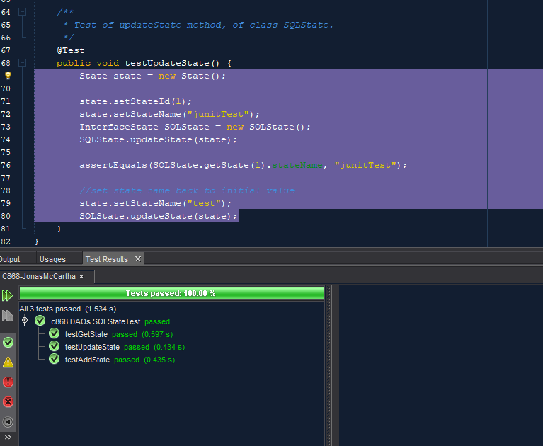

C4. Source Code
All source code and files are included in the C868-JonasMcCartha folder within the zip file. By default, a user with the username “admin” and a password of “password” is already in the database.

User Guide

Introduction
Welcome to the user guide for Acme Health Clinics' Patient/Appointment Scheduler app. Over the course of the following several pages, we'll walk you though installing the app, logging in for the first time, and step-by-step instructions through the various features. Use this guide as a quick-start guide, or as a reference once you get more accustomed to the application. Going through this guide when you first introduce yourself to the application should make the learning process easier.

Installation
To officially install the program on to your system, run the file called C868PatientSchedulerInstaller.exe. Follow the steps in the install wizard that opens up. By default, the program will be installed into C:\Program Files\C868 Patient Scheduler. You can run the program for the first time from the install wizard, after the install is finished. You can also run the program from the start menu after installation. Once you've opened up the program for the first time, continue to the “Using the Application” section below.

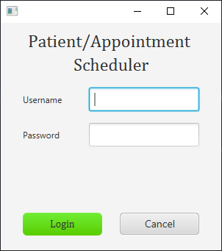
Using the Application

Login and Signup
- Type in your username and password and press enter(or click Login) to access the main menu. The first time the application is initialized, a default user with the username of “admin” and a password of “password” will allow you to access the app.
- Please contact your database administrator to create new user accounts. Any existing user accounts can change their own password once logged in.
- Click “Cancel” to close the app completely.

Main Menu
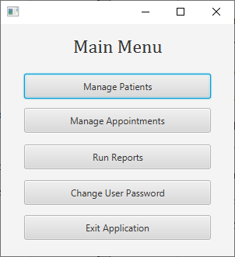
- The Main Menu is the central branch from which all the main features of the app are accessed. You'll find five buttons: “Manage Patients”, “Manage Appointments”, “Run Reports”, “Change User Password”, and “Exit Application”
- Click “Manage Patients” to access a list of patients, from where you can add and delete patients, as well as modify existing patient data.
- Click “Manage Appointments” to access a calendar view of appointments, where you can add, delete, and manage existing appointments. You need patient data to create appointments, so make sure you create a patient in “Manage Patients” before you try to make an appointment for them.
- Click “Run Reports” to access a menu of various reports you can run.
- Click “Change User Password” to change the password for your current account. You can only change the password for the user you are logged in as. For more complex user management needs, please contact the administrator.
- Click “Exit Application” to close the app.

Manage Patients
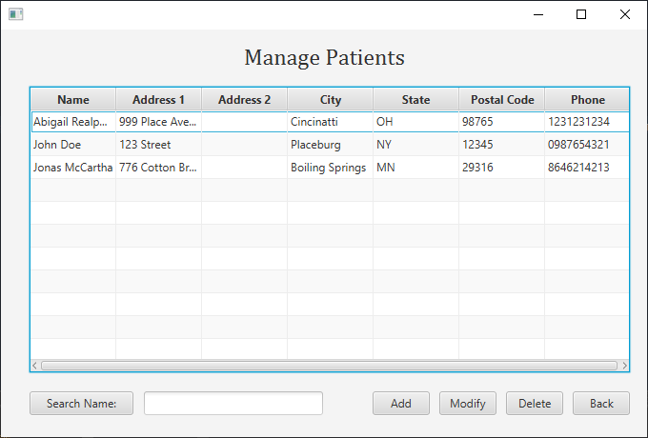
- The Manage Patients screen shows a list of patients and relevant patient data. You can organize this list by of the columns by click on the column name.
- Type in a name and click “Search Name:” to search for a patient by name. You can type in just a first name or last name, or both combined.
- The buttons on the bottom right will allow to further navigate this section, or return to the main menu. Click on “Add” to go an Add/Modify Patient screen, which will be covered in the next segment. Click on a patient in the list and click “Modify” to go to a screen where you can modify that patient's data. Click on a patient and click “Delete” to delete a given patient completely. You'll get a prompt asking if you're sure you want to do this. Click “Back” to return to the main menu.

Add/Modify Patient
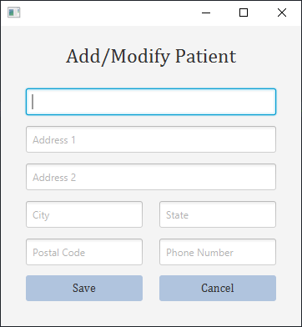
  - This screen allow you to add a new patient to the system, or modify an existing patient.
  - If you clicked “Add” on the previous screen, all the fields will be blank. Enter all relevant data, then click “Save” to return the previous screen, where you will see the new patient in the list of patients. Or, click cancel to return to the previous screen without saving.
  - If you choose an existing patient and clicked “Modify” on the previous screen, that patient's data will now appear. Change any information you like for this patient, then click “Save”, and you will see that patient's data updated in the list on the “Manage Patients” screen. If you click “Cancel”, you'll return to the previous screen, and no changes you made will be saved.

Manage Appointments
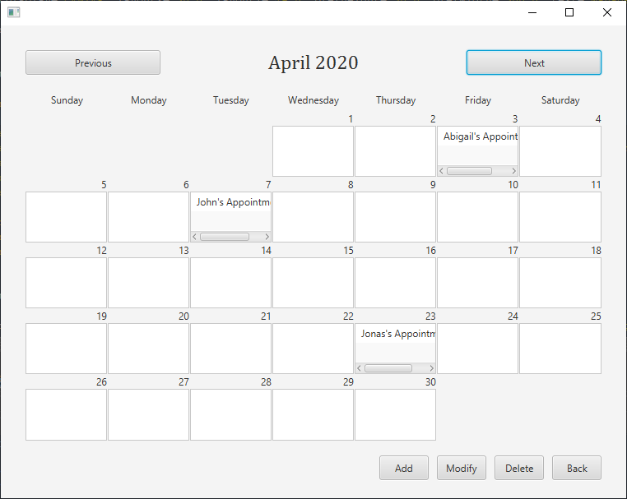
- The Manage Appointments screen is a monthly calendar view where you can view, add, delete, and modify appointments. Click “Previous” or “Next” to navigate to the previous or next month, respectively.
- Click “Add” to go to the Add/Modify Appointment screen, which will be covered in the next segment. Click on an appointment and then click “Modify” to modify the data of an appointment, including the date and time of the appointment. Click an appointment and click “Delete” to completely remove an appointment.
- Click “Back” to return to the previous screen.

Add/Modify Patient
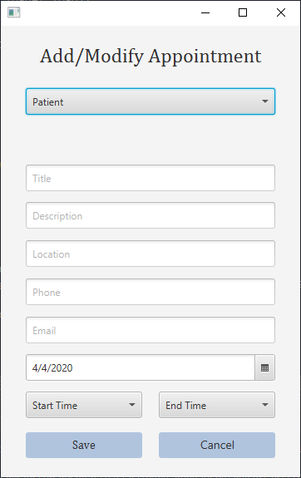
- This screen allows you to add a new appointment to the system, or change an existing appointment.
- If you clicked “Add” on the previous screen, all the fields will be blank. Enter all relevant data, then click “Save” to return the previous screen, where you will see the new appointment in the calendar view. Or, click cancel to return to the previous screen without saving.
- If you choose an existing appointment and clicked “Modify” on the previous screen, that appointment's data will now appear. Change any information you like, then click “Save”. If you click “Cancel”, you'll return to the previous screen, and no changes you made will be saved.

Run Reports
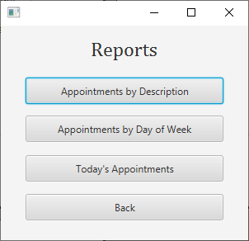
- The reports screen contains a list of buttons that take you to various report screens.
- The “Appointments by Description” report groups and counts appointments by what has been entered in the 'description' field.
- The “Appointments by Day of Week” report groups and counts appointments by day of the week(i.e. the number of appointments on monday, the number of appointments on tuesday, etc.).
- The “Today's Appointments” shows you a list of appointments scheduled for today's date.
- Click “Back” to return to the previous screen.

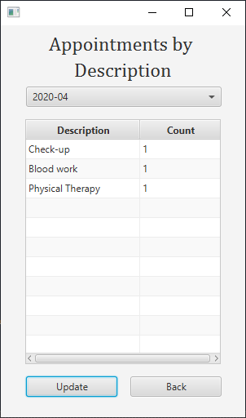
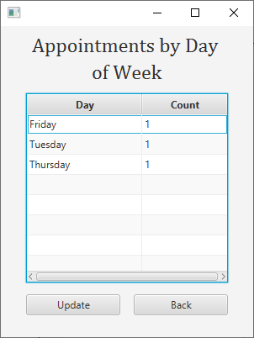
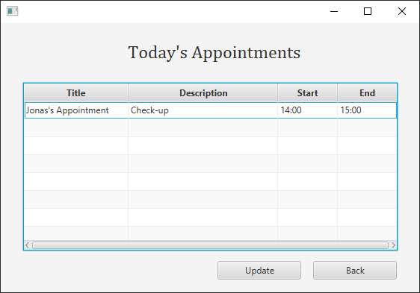
Report Examples

